LAB 5
TASK 1
1.Catplot
o Create a bar catplot to compare average body mass across species and sex.
o Title: "Average Body Mass by Species and Sex"
o X-axis: Species
o Y-axis: Body Mass (g)
o Hue: Sex

INPUT
data_by_avg_body_mass = data.groupby(["species","sex"])['body_mass_g'].mean().reset_index()
sns.catplot(data=data_by_avg_body_mass, x="species", y='body_mass_g', hue='sex', kind='bar')
plt.savefig("Image1.png")

OUTPUT
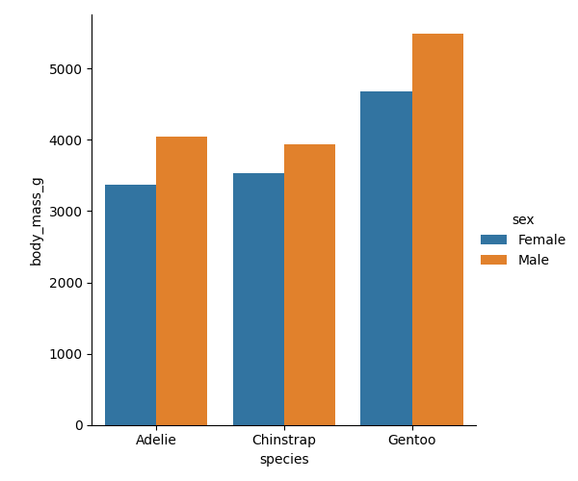
TASK 2
2. Stripplot
o Visualize flipper length distribution by species and sex.
o Title: "Flipper Length Distribution by Species and Sex"
o X-axis: Species
o Y-axis: Flipper Length (mm)

INPUT
sns.stripplot(data=data, x="species", y='flipper_length_mm', hue='sex')
plt.title("Flipper length Distribution by species and Sex")
plt.xlabel("Species")
plt.ylabel("Flipper")
plt.savefig("Image2.png")
OUTPUT
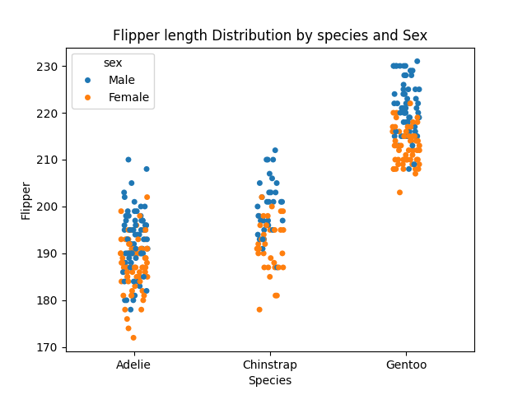
TASK 3
3. Heatmap
- Display correlation matrix of numerical features (bill length, bill depth, flipper length, body ,
mass)
- Annotate values, use colorbar to represent correlation strength.
- Title: "Correlation Heatmap of Penguin Features

INPUT
new_data = data.drop(['species', 'island', 'sex'], axis = 1)
data_corr = new_data.corr()
sns.heatmap(data=data_corr, annot=True, cmap='binary')
plt.title("Correlation heatmap of Penguin Features")
plt.savefig("Image3.png")
OUTPUT
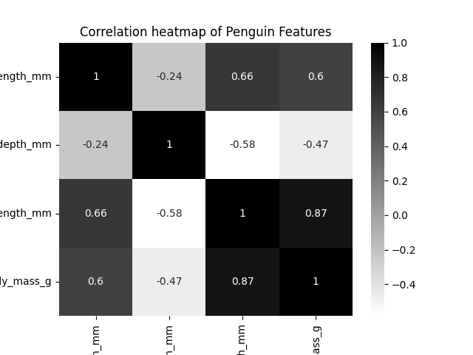
TASK 4
4. Clustermap
o Create a clustered heatmap to group features based on similarity.
o Title: "Clustered Correlation Map of Penguin Features”
INPUT
sns.clustermap(data=data_corr, annot=True, cmap='binary')
plt.title("Clustered Correlation Map of Penguin Features")
plt.savefig("Image4.png")
OUTPUT
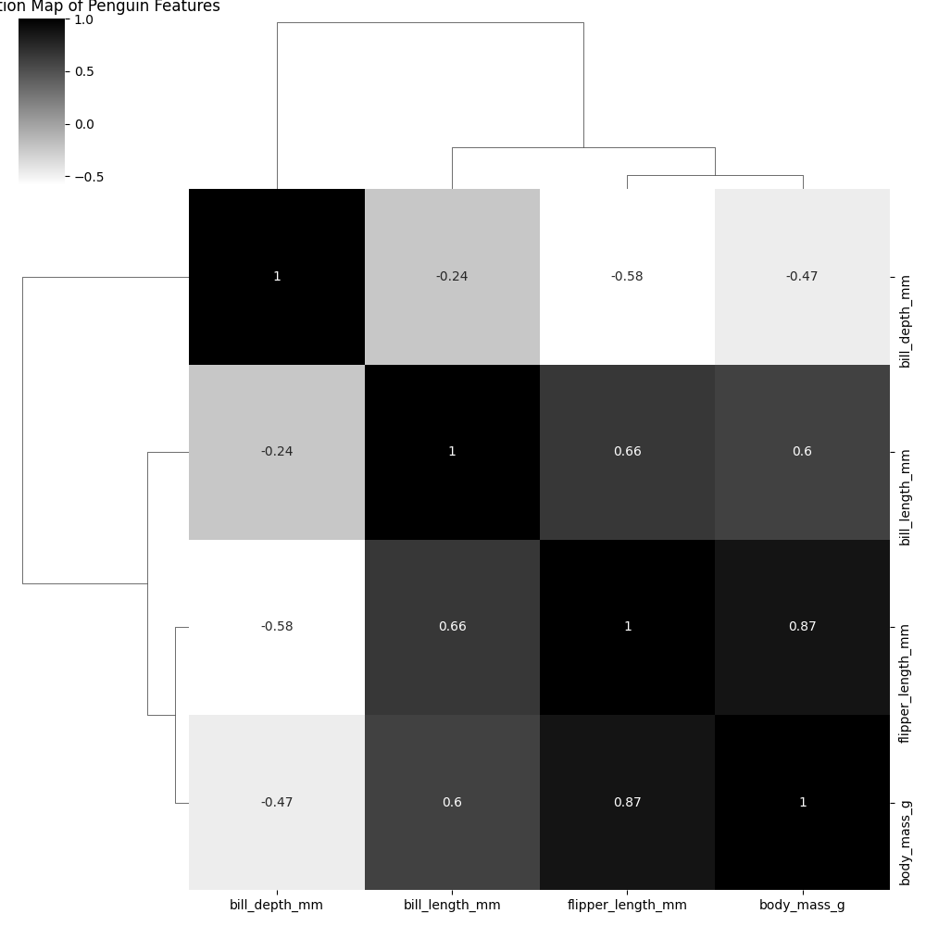
TASK 5
5. Box Plot
o Compare total bill distribution across days.
o Title: "Total Bill Distribution by Day"
o X-axis: Day
o Y-axis: Total Bill

INPUT
sns.boxplot(data=data2, x='day', y='total_bill')
plt.title("Total bill Distribution by day")
plt.xlabel("Day")
plt.ylabel("Total bill")
plt.savefig("Image5.png")
OUTPUT
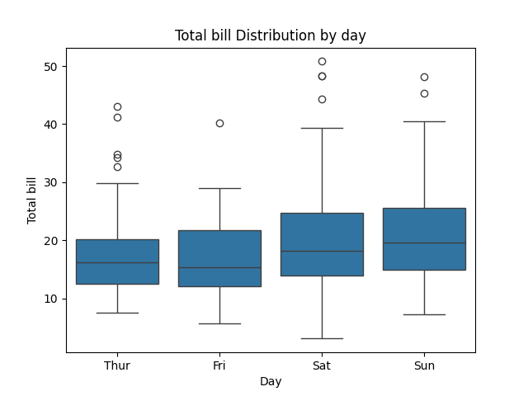
TASK 6
6. PViolin Plot
o Showtip distribution by smoker status.
o Title: "Tip Distribution by Smoker Status"
o X-axis: Smoker
o Y-axis: Tip

INPUT
sns.violinplot(data=data2,x='smoker', y='tip')
plt.title("Tip distribution by smoker status")
plt.savefig("Image6.png")
plt.show()
OUTPUT
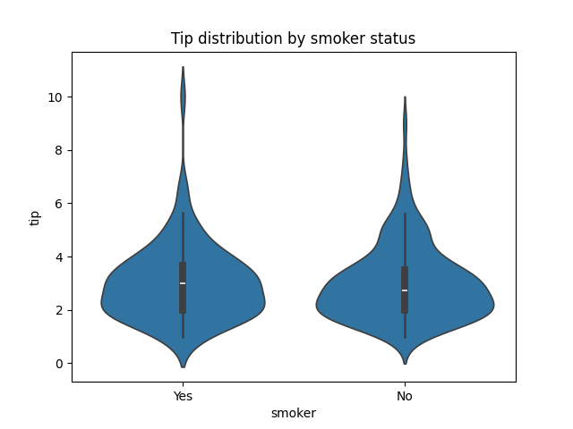
TASK 7
7. KDEPlot
o Plot density of total bill amounts split by gender.
o Title: "Density of Total Bill by Gender"
o X-axis: Total Bill
o Hue: Gender

INPUT
sns.kdeplot(data=data2, x="total_bill", hue='sex')
plt.title("Density of Total Bill by Gender")
plt.xlabel("Total bill")
plt.ylabel("Gender")
plt.savefig("Image7.png")
OUTPUT
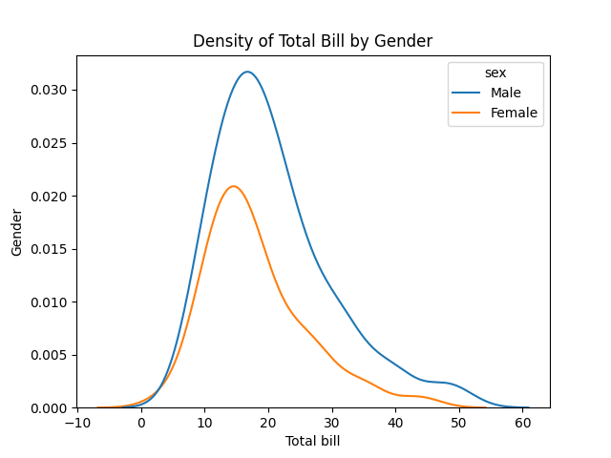
TASK 8
8. Joint Plot
o Explore relationship between total bill and tip.
o Title: "Total Bill vs Tip Relationship"
o X-axis: Total Bill
o Y-axis: Tip
o Hue: Gender

INPUT
sns.jointplot(data=data2, x="total_bill",y="tip",kind="scatter", hue='sex')
plt.suptitle("Total Bill vs Tip Relationship", y=1.05)
plt.xlabel("Total bill")
plt.ylabel("Tip")
plt.savefig("Image8.png")
OUTPUT
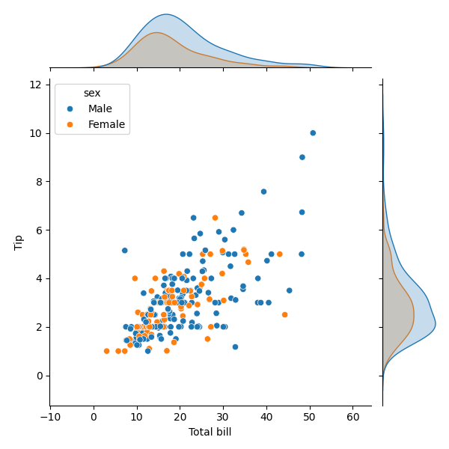
TASK 9
9. Pairplot
o Create pairwise relationships among all numeric features.
o Title: "Pairwise Relationships in Iris Dataset"
o Hue: Species

INPUT
sns.pairplot(data=data3, hue='species')
plt.suptitle("Pairwise Relationship in Iris Dataset", y=1.02)
plt.savefig("Image9.png")
OUTPUT
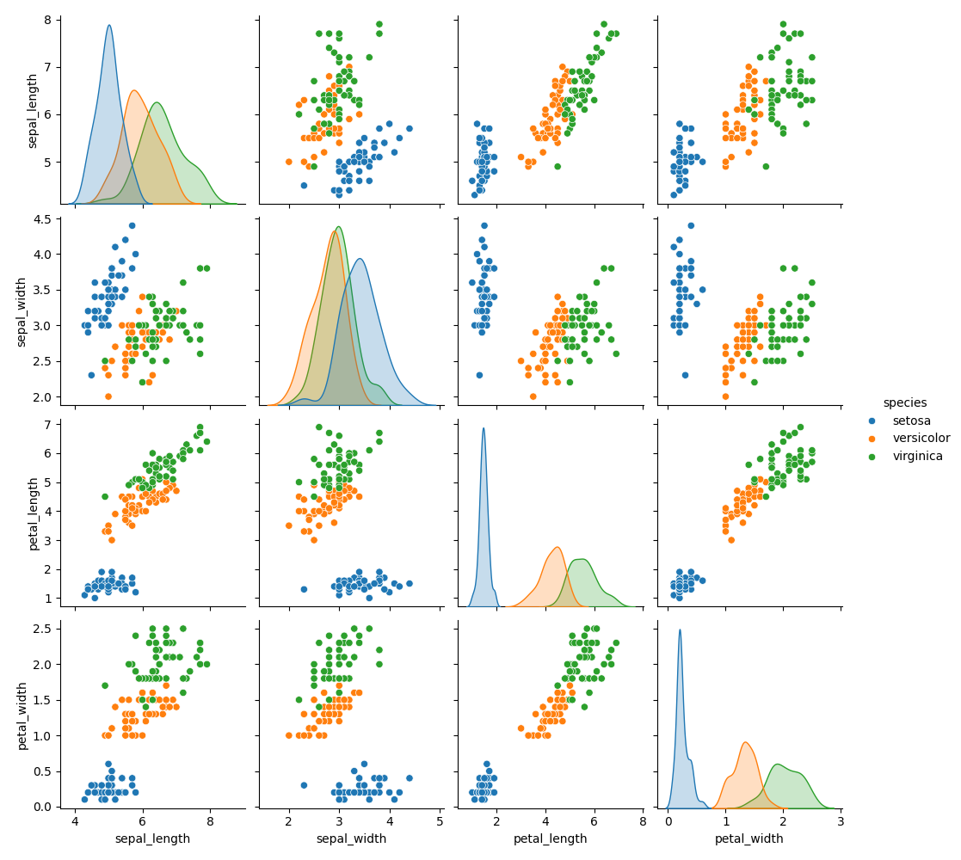
TASK 10
10. SwarmPlot
o Visualize petal length distribution across species.
o Title: "Petal Length Distribution by Species"
o X-axis: Species
o Y-axis: Petal Length

INPUT
sns.swarmplot(data=data3, hue='species', x='petal_length')
plt.suptitle("Pairwise Relationship in Iris Dataset", y=1.02)
plt.xlabel("Species")
plt.ylabel("Petal Length")
OUTPUT
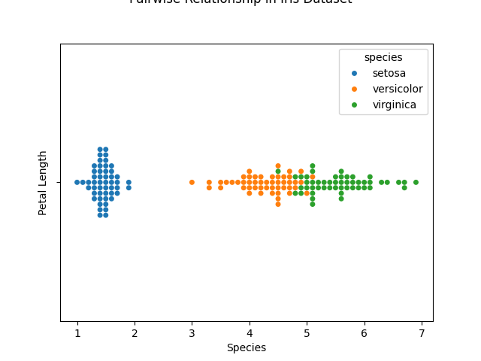
TASK 11
10. Bubble Chart (Scatterplot with size)
o Sepal length vs sepal width
o bubble size = petal length
o hue = species.
o Title: "Sepal vs Petal Dimensions in Iris"

INPUT
sns.scatterplot(data=data3,x='sepal_length',y='sepal_width',size='petal_length',hue='species',sizes=(20, 200), alpha=0.7)
plt.suptitle("Sepal vs Petal Dimensions in Iris", y=1.02)
plt.xlabel("Sepal Length")
plt.ylabel("Sepal Width")
plt.legend(bbox_to_anchor=(1.05, 1), loc='upper left')
plt.show()
OUTPUT
